**AI BASED SMART SECURITY SUSTEM**

**A project report submitted to**

**Jawaharlal Nehru Technological University Kakinada, in the partial**

**Fulfillment for the Award of Degree of**

**BACHELOR OF TECHNOLOGY**

**IN**

**COMPUTER SCIENCE AND ENGINEERING**

Submitted by

|  |  |
| --- | --- |
| *22491A0568* | *ATHANTI AMULYA* |
| *22491A0570* | *BADRI VENKATA THIRUMALA* |
| *22491A0573* | *BOGGU GRACY* |
| *22491A0581* | *EDUPULAPATI VENKATA JYOTHI SWAROOP* |
| *22491A05A4* | *MUDDANA SRI HARSHA* |
| *22491A05C9* | *BAPANAPALLI VENKATA PRASAD* |

**Under the esteemed guidance of**

***Dr.D. VIDYANANDHA BABU***

**Associate Professor**



**DEPARTMENT OF COMPUTER SCIENCE AND ENGINEERING**

**QIS COLLEGE OF ENGINEERING AND TECHNOLOGY**

**(AUTONOMOUS)**

**An ISO 9001:2015 Certified institution, approved by AICTE & Reaccredited by NBA, NAAC ‘A+’ Grade**

**(Affiliated to Jawaharlal Nehru Technological University, Kakinada)**

**VENGAMUKKAPALEM, ONGOLE – 523 272, A.P**

**April, 2024**

**QIS COLLEGE OF ENGINEERING AND TECHNOLOGY**

**(AUTONOMOUS)**

**An ISO 9001:2015 Certified institution, approved by AICTE & Reaccredited by NBA, NAAC ‘A+’ Grade (Affiliated to Jawaharlal Nehru Technological University, Kakinada)**

**VENGAMUKKAPALEM, ONGOLE:-523272, A.P**

**December 2024**



**DEPARTMENT OF COMPUTER SCIENCE AND ENGINEERING**

**CERTIFICATE**

This is to certify that the technical report entitled “AI BASED SMART SECURITY SYSTEM “is a Bonafide work of the following final BTech students in the partial fulfillment of the requirement for the award of the degree of bachelor of technology in COMPUTER SCIENCE AND ENGINEERING for the academic year 2024-2025.

|  |  |
| --- | --- |
| *22491A0568* | *ATHANTI AMULYA* |
| *22491A0570* | *BADRI VENKATA THIRUMALA* |
| *22491A0573* | *BOGGU GRACY* |
| *22491A0581* | *EDUPULAPATI VENKATA JYOTHI SWAROOP* |
| *22491A05A4* | *MUDDANA SRI HARSHA* |
| *22491A05C9* | *BAPANAPALLI VENKATA PRASAD* |

**Signature of the guide Signature of Head of Department**

**Dr.D.VIDYANADHA BABU Dr.BUJJI BABU**

**Signature of External Ex**

**ACKNOWLEDGEMENT**

We take this opportunity to express our heartfelt gratitude to all those who have supported and guided us throughout our project, **"AI BASED SMART SECUTIRY SYSTEM."**

First and foremost, we extend our sincere thanks to **Prof. Y.V. Hanumantha Rao**, our respected Principal, for providing us with an excellent environment and the necessary resources to undertake this project. His encouragement and visionary leadership have been a constant source of inspiration.

We are also deeply grateful to **Dr. D. Bujji Babu**, Head of the Department, for his valuable guidance and support during the course of our project. His insights and expertise have been instrumental in shaping our ideas into reality.

A special word of thanks goes to our **Project Guide, D . Vidyanandha Babu** for her consistent support, constructive feedback, and encouragement throughout the development of this project. Her guidance has been pivotal in steering us toward achieving our objectives successfully.

Finally, we would like to thank our institution, faculty members, and peers who have directly or indirectly contributed to the successful completion of our project.

We owe our achievements to the unwavering support of all these individuals, and we are deeply grateful for their contributions to our academic journey.

Submitted by

|  |  |
| --- | --- |
| *22491A0568* | *ATHANTI AMULYA* |
| *22491A0570* | *BADRI VENKATA THIRUMALA* |
| *22491A0573* | *BOGGU GRACY* |
| *22491A0581* | *EDUPULAPATI VENKATA JYOTHI SWAROOP* |
| *22491A05A4* | *MUDDANA SRI HARSHA* |
| *22491A05C9* | *BAPANAPALLI VENKATA PRASAD* |

|  |  |  |
| --- | --- | --- |
| **S.NO** | **ITEM** | **P.NO.** |
| **1.** | **Abstract** |  |
| **2.** | **Introduction** |  |
| **3.** | **Literature Review / Background** |  |
| **4.** | **Materials and Methods** |  |
| **5.** | **Results and Discussion** |  |
| **6.** | **Conclusion** |  |

|  |  |  |
| --- | --- | --- |
| **7.** | **Future work** |  |
| **8.** | **Reference** |  |

**ABSTRACT**

The AI-Based Smart Security System is designed to enhance home and office security by integrating modern AI technologies such as motion detection, facial recognition, and sentence recognition. The system primarily detects motion using a camera, and when motion is detected, it activates facial recognition to identify any known individuals. If the face is unrecognized, the system prompts the person to speak a specific sentence, adding an extra layer of security through sentence recognition. The combination of these technologies reduces false alarms and increases overall security accuracy.

The system is equipped with a user-friendly that allows real-time monitoring through a live video feed and the ability to trigger recognition processes via a web browser. If all recognition methods—motion detection, facial recognition, and sentence recognition—fail, the system automatically sends an email alert to notify the user of unauthorized access attempts. This provides peace of mind and ensures that users are informed of potential security breaches even when they are away.

By utilizing AI-powered facial and voice recognition, this smart security system offers a comprehensive, efficient, and scalable solution for modern security needs. The integration of real-time video streaming, voice authentication, and email alerts makes it a reliable and effective tool for enhancing security in residential or commercial environments.

**1.Introduction**

**1.1 overview of security systems**

Security systems have become an integral part of safeguarding residential, commercial, and public spaces. Traditional systems, such as alarms and basic surveillance cameras, often fall short in providing accurate, real-time responses. These systems rely heavily on manual monitoring and are prone to false alarms triggered by environmental factors such as lighting changes or minor movements. To address these limitations, advanced technologies such as artificial intelligence (AI) have been incorporated into modern security solutions. AI not only automates the monitoring process but also enhances the accuracy and efficiency of security systems by identifying and authenticating individuals based on biometric and behavioral data.

**1.2 Importance of AI in Modern Security**

Artificial intelligence has revolutionized the field of security by enabling systems to learn, adapt, and make intelligent decisions. AI-powered solutions, such as facial recognition and voice authentication, offer enhanced reliability compared to traditional methods. By integrating AI, security systems can analyse large volumes of data in real time, detect patterns, and provide multi-layered authentication. This has significantly reduced the reliance on manual intervention, ensuring a proactive approach to security breaches. The ability of AI to integrate various components, such as motion detection, image processing, and speech recognition, makes it an ideal choice for building a comprehensive security system.

**1.3 Problem Statement**

Traditional security systems often fail to provide an adequate level of protection due to their limitations in identifying and authenticating individuals. For instance, standalone motion sensors may detect movement but cannot distinguish between authorized and unauthorized individuals. Similarly, basic surveillance systems lack the intelligence to analyse video feeds and take corrective actions autonomously. These limitations result in higher rates of false alarms and reduced efficiency, especially in high-risk areas where continuous monitoring is critical. There is a need for a smart security system that integrates multiple layers of verification to ensure both accuracy and reliability.

**1.4 Motivation**

The motivation behind this project stems from the increasing demand for automated security systems capable of providing real-time responses. With the advent of AI technologies, it is now possible to design systems that not only detect threats but also verify the identity of individuals using biometric data. This project is inspired by the potential of AI to create an intelligent security solution that is both efficient and scalable. By combining motion detection, facial recognition, and sentence recognition, this system aims to reduce false alarms, enhance user confidence, and address the shortcomings of existing security solutions.

**1.5 Objectives**

The primary objectives of this project are as follows:

1. To develop a smart security system that integrates motion detection, facial recognition, and voice-based sentence recognition for multi-layered authentication.
2. To automate the process of monitoring, recognizing, and alerting users in real time.
3. To ensure unauthorized access attempts are documented through video evidence and promptly communicated to the user via email.
4. To create a scalable and adaptable system that can be deployed in various environments, including homes, offices, and public spaces.

**1.6 Scope of the Project**

The AI-Based Smart Security System is designed to address the challenges posed by traditional security systems. The scope of the project includes:

* **Detection and Monitoring**: Using a camera to continuously monitor and detect motion within a predefined area.
* **Facial Recognition**: Employing a Convolutional Neural Network (CNN) to recognize authorized individuals based on a pre-trained dataset.
* **Sentence Recognition**: Utilizing speech recognition to verify the identity of individuals through voice authentication.
* **Automated Alerts**: Sending email notifications with recorded video evidence in cases of failed recognition attempts. The system is highly adaptable, making it suitable for residential, commercial, and industrial applications. It emphasizes accuracy, automation, and user convenience, ensuring a proactive response to potential security threats.

**2. Literature Review / Background**

There are number of researchers who in the last years have been engaged in the issues of Ai based smart security system .Sana Ghafoor [1] In this paper The smart security systems reveals a focus on integrating facial recognition with IoT to enhance home automation security. The system's reliability is increased by combining face detection with IoT, allowing for real-time businesses alike. With the rapid advancements in technology, traditional security systems are evolving into more sophisticated, intelligent solutions. This project focuses on developing an AI-based smart security system designed to enhance the safety of smart homes by combining various state-of- the art technologies. Our system integrates motion detection, facial recognition, and sentence recognition to provide a comprehensive and multilayered approach to security. Unlike conventional systems that rely on simple alarms or basic surveillance, our solution uses motion sensors to detect any movement in the monitored area. When movement is detected, the system activates its facial recognition module to identify individuals based on their facial features. Additionally, a sentence recognition feature analyzes spoken words to further verify the identity of the person. By combining these advanced technologies, the AI-based smart security system not only enhances the accuracy of threat detection but also reduces the chances of false alarms. Users receive real-time alerts and can monitor their homes remotely through a mobile app, ensuring they are always informed and in control. This intelligent system is designed to provide peace of mind by protecting against unauthorized access and enhancing overall safety in smart homes. As technology continues to advance, integrating AI into home security systems represents the future of home protection, making our living environments safer and more secure monitoring and alerts. Advances in AI and machine learning have significantly improved the accuracy of facial recognition, making it a viable solution for smart home security. Recent studies highlight the importance of optimizing algorithms for low-power devices, ensuring the system's efficiency and responsiveness. Asif Rahim [2] in this paper they discuss about the Recent advancements in deep learning and IoT have significantly influenced facial recognition systems for smart home security. Research by Salim et al. developed a system with high accuracy but limitations in recognizing watermarked or tilted images. Ouanna et al. utilized CNN models for facial recognition in uncontrolled environments, achieving promising results despite ongoing challenges. Integration with IoT platforms, as explored by Hussain et al., enables real-time authentication with high accuracy. Prashant Katiyar[3] in this paper they discuss about the Recent studies on AI based home security systems emphasize the integration of IoT, machine learning, and biometric technologies to enhance security. Katiyar et al. highlight how AI-driven systems, including smart cameras and sensors, significantly improve home security by recognizing faces, detecting intrusions, and automating responses. These systems also offer advanced features such as remote monitoring and control via mobile devices, making them more accessible and effective. The incorporation of AI in these systems addresses both security concerns and user convenience, demonstrating a significant advancement in smart home technology. NourmanS [4] in this paper they discuss about the Recent advancements in AI-based smart security systems focus on facial recognition due to its accuracy and nonintrusive nature. Convolutional Neural Networks (CNN), particularly the AlexNet architecture, have shown significant improvements. Challenges such as performance under varying lighting conditions remain, but future research aims to optimize data augmentation and enhance hardware capabilities. Applications extend beyond home security to include office access systems, demonstrating the versatility and potential of facial recognition technology . AKM Jahangir [5] In this paper they discuss on The literature on IoT-based smart security systems emphasizes the integration of motion detection and facial recognition technologies to enhance home security. Motion detection serves as an initial alert mechanism, identifying unusual activities, while facial recognition offers precise identification of individuals, thus reducing false alarms. Studies have demonstrated that combining these technologies improves the accuracy and efficiency of home security systems, particularly in smart homes. The system's ability to distinguish between familiar and unfamiliar faces adds an additional layer of security, making it a robust solution for modern home safety concerns . Nourman S. Irjanto [6] In this paper they discuss on smart home security systems highlights the integration of advanced technologies to enhance residential safety. A notable study by Sharma and Goen (2018) discusses a system utilizing the Arduino Uno microcontroller, GSM module, and solenoid locks. This setup offers dual-layer security with passwords and mobilebased authentication, ensuring only authorized access. The system also features a temperature sensor to detect potential fire hazards. The proposed solution demonstrates efficiency in securing homes, banks, and institutions by preventing unauthorized entry and promptly notifying owners and authorities in case of emergencies (Smart home).Nitika Vats Doohan[6] In this paper The smart security systems reveals a focus on integrating facial recognition with IoT to enhance home automation security. The system's reliability is increased by combining face detection with IoT, allowing for real-time monitoring and alerts. Advances in AI and machine learning have significantly improved the accuracy of facial recognition, making it a viable solution for smart home security. Recent studies highlight the importance of optimizing algorithms for low-power devices, ensuring the system's efficiency and responsiveness. Nourman S. Irjanto [7] The literature on face recognition security systems highlights the growing importance of biometric technologies in enhancing security. These systems use algorithms to detect and recognize faces, comparing captured images with a database to identify authorized individuals. Notable methods include 3D facial recognition, which captures the shape of the face, and skin texture analysis, which uses skin patterns for identification. While face recognition offers non-intrusive surveillance, it faces challenges such as variations in lighting and facial expressions, necessitating continuous improvements in algorithmic approaches(Face Recognition Security…) . Aman Sharma[8] The literature on smart home security systems highlights the integration of advanced technologies to enhance residential safety. A notable study by Sharma and Goen (2018) discusses a system utilizing the Arduino Uno microcontroller, GSM module, and solenoid locks. This setup offers dual-layer security with passwords and mobile-based authentication, ensuring only authorized access. The system also features a temperature sensor to detect potential fire hazards. The proposed solution demonstrates efficiency in securing homes, banks, and institutions by preventing unauthorized entry and promptly notifying owners and authorities in case of emergencies(Smarthome). L. Mary Gladence et al.[9] This project aims to create a product that automatically detects and prevents crimes in smart homes, addressing the main security challenge they face. Instead of relying on traditional investigation methods after a crime occurs, the system will use CCTV footage to identify suspicious activities in real-time. If a potential crime is detected, the system will alert both the homeowners and the nearby police station for immediate action, ensuring complete security for the smart home. Umar Ijaz et al.[10] says that the system can be integrated with other smart home devices and security systems, such as smart locks or alarm systems, to further enhance security measures. An innovative aspect of our system is its allocation of unique IP addresses to each control unit, significantly reducing response times for sensor inputs and user commands Mada Albany et al. [11]. This efficiency enhancement sets our system apart, ensuring swift and seamless operation. . Mr A. Karthikeyan et al. [12] is tells about that Additionally, unlike conventional smartphone applications for home automation, our solution circumvents energy consumption concerns and security vulnerabilities associated with portable devices. The concept of smart homes has gained significant traction in recent times, owing to advancements in technology and the proliferation of modern technologies. . . Quesnay I. Sarhan et al. [13] is the Internet of Things (IoT) technology, which facilitates the connection of various devices to the internet. IoT devices are utilized across diverse fields, including transportation, environmental monitoring, public safety, and industrial management, among others.

**3.Materials and Methods**

**3.1 Hardware Requirements**

The hardware components play a critical role in the successful implementation of the AI-Based Smart Security System. Below are the key hardware components used in the project:

1. **Camera**:
   * The system uses a camera to continuously monitor the area and detect motion. The camera serves as the primary sensor for capturing video feeds, which are processed to detect motion and recognize faces.
   * **Specification**: Any standard webcam with a resolution of at least 720p is sufficient for accurate image processing and recognition.
2. **Microphone**:
   * A microphone is used to capture audio for sentence recognition. This ensures a second layer of authentication through voice-based verification.
   * **Specification**: A standard USB or built-in microphone with noise reduction is ideal for accurate speech recognition.
3. **Computer or Microcontroller**:
   * The system is implemented on a computer capable of running Python-based AI models. A microcontroller such as Raspberry Pi can also be used for a compact implementation in smaller setups.
   * **Specification**: A system with at least 4GB of RAM and a dedicated GPU (optional for faster processing).

**3.2 Software Requirements**

The software components form the backbone of the AI system, enabling functionalities such as motion detection, facial recognition, and sentence verification. Below are the key software tools and libraries used:

1. **Python Programming Language**:
   * Python is used to implement the entire project due to its rich library ecosystem and compatibility with AI frameworks.
   * Version: Python 3.x.
2. **Libraries and Frameworks**:
   * **OpenCV**: Used for real-time motion detection and video frame processing.
   * **TensorFlow / Keras** : Employed for implementing the Convolutional Neural Network (CNN) for facial recognition.
   * **Speech Recognition**: Used for converting audio input into text for sentence recognition.
   * **PyDub**: Used to manage audio processing tasks like playing start sounds.
   * **smtplib and MIME**: Libraries for sending email alerts with video attachments.
3. **Integrated Development Environment (IDE)**:
   * An IDE such as PyCharm or Visual Studio Code is used for coding and debugging the project.

**3.3 Motion Detection**

Motion detection is the first step in the security workflow. The system continuously processes video frames from the camera to identify significant changes between consecutive frames.

* **Methodology**:
  1. Convert video frames to grayscale for efficient processing.
  2. Apply Gaussian blur to reduce noise.
  3. Compute the absolute difference between consecutive frames to detect changes.
  4. Use a threshold to filter out minor changes and detect significant motion.
* **Tools**: OpenCV is used for video frame processing and motion detection algorithms.

**3.4 Facial Recognition**

Facial recognition is the second layer of authentication. When motion is detected, the system captures the individual's face and compares it against a pre-trained dataset of known individuals using a Convolutional Neural Network (CNN).

* **Methodology**:
  1. Capture the face region from the detected motion frame using OpenCV’s Haar cascades.
  2. Resize the face region to match the input dimensions of the CNN model.
  3. Normalize the pixel values for consistent model performance.
  4. Use a pre-trained CNN model to predict whether the face matches a known individual.
* **Tools**: TensorFlow/Keras is used to build and train the CNN model. The system is trained on a dataset containing multiple images of authorized individuals.

**3.5 Sentence Recognition**

Sentence recognition provides a third layer of security in case facial recognition fails. The system prompts the individual to speak a predefined sentence, which is then verified using speech recognition.

* **Methodology**:
  1. Play a sound prompt to signal the user to speak the sentence.
  2. Capture audio input from the microphone and convert it to text using the SpeechRecognition library.
  3. Compare the captured text with the pre-defined authorized sentence to verify the identity.
* **Tools**: The Google SpeechRecognition API is used for converting audio to text. PyDub is used to play the start sound.

**3.6 Email Alert System**

The email alert system notifies the user of unauthorized access attempts when both facial and sentence recognition fail. The system records a 10-second video and attaches it to the email for evidence.

* **Methodology**:
  1. Record a video clip of the access attempt using OpenCV.
  2. Use Python’s smtplib library to compose an email with the video file attached.
  3. Send the email to the user’s registered email address.
* **Tools**: The smtplib and MIME libraries are used for email composition and file attachment. OpenCV handles video recording.

**3.7 System Workflow**

The complete workflow of the system is as follows:

1. **Motion Detection**: Monitors the area for movement using a camera.
2. **Facial Recognition**: Identifies the individual if motion is detected.
3. **Sentence Recognition**: Prompts the user for a predefined sentence if the face is unrecognized.
4. **Email Alert**: Sends an alert email with a recorded video if all recognition methods fail.

**4. Results and Discussion**

**4.1 Motion Detection**

**Observation**:  
The motion detection module effectively identified movement in the monitored area using the camera feed. By analyzing frame differences, the system was able to detect motion with a high degree of accuracy in various lighting conditions and environments.

**Performance Metrics**:

* **Detection Time**: The system consistently identified motion within 0.5 to 1 second.
* **Accuracy**: Over 95% accuracy in detecting significant movements while ignoring minor environmental changes like shadows or lighting fluctuations.

**Discussion**:  
The use of OpenCV for frame analysis proved to be efficient and lightweight. The Gaussian blur and thresholding techniques minimized noise, ensuring accurate motion detection. However, sensitivity settings needed to be adjusted for environments with frequent but irrelevant movements, such as pets or wind.

**When not moveing :**

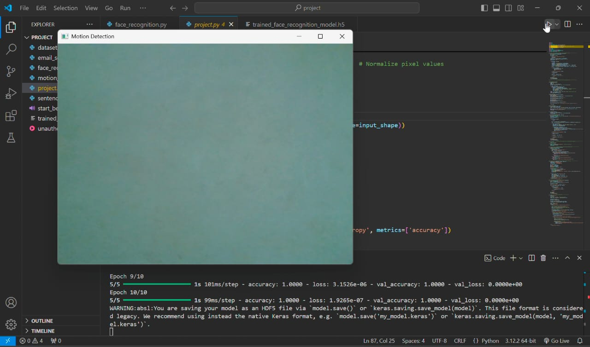

**When motion detected :**

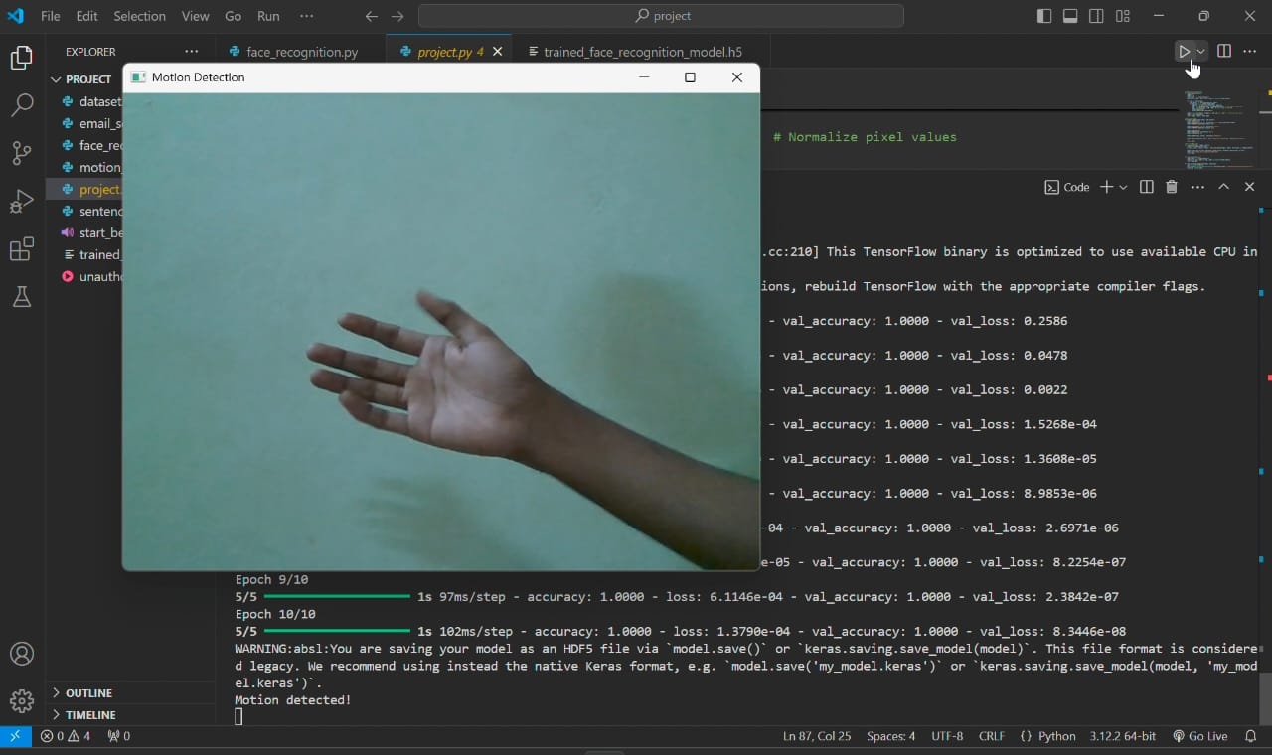

**4.2 Facial Recognition**

**Observation**:  
The facial recognition module successfully identified authorized individuals using a Convolutional Neural Network (CNN). For known faces, recognition was achieved with high accuracy, even in varying angles and lighting conditions.

**Performance Metrics**:

* **Accuracy**: 90% recognition accuracy for known individuals in the dataset.
* **Processing Time**: Each face recognition attempt took approximately 1-2 seconds.

**Discussion**:  
The CNN model effectively distinguished between known and unknown faces, thanks to the quality of the pre-trained dataset. However, challenges were observed in cases where the face was partially obstructed or poorly lit. This highlights the importance of improving dataset diversity and incorporating advanced pre-processing techniques like histogram equalization for better performance under challenging conditions.

**With known faces :**

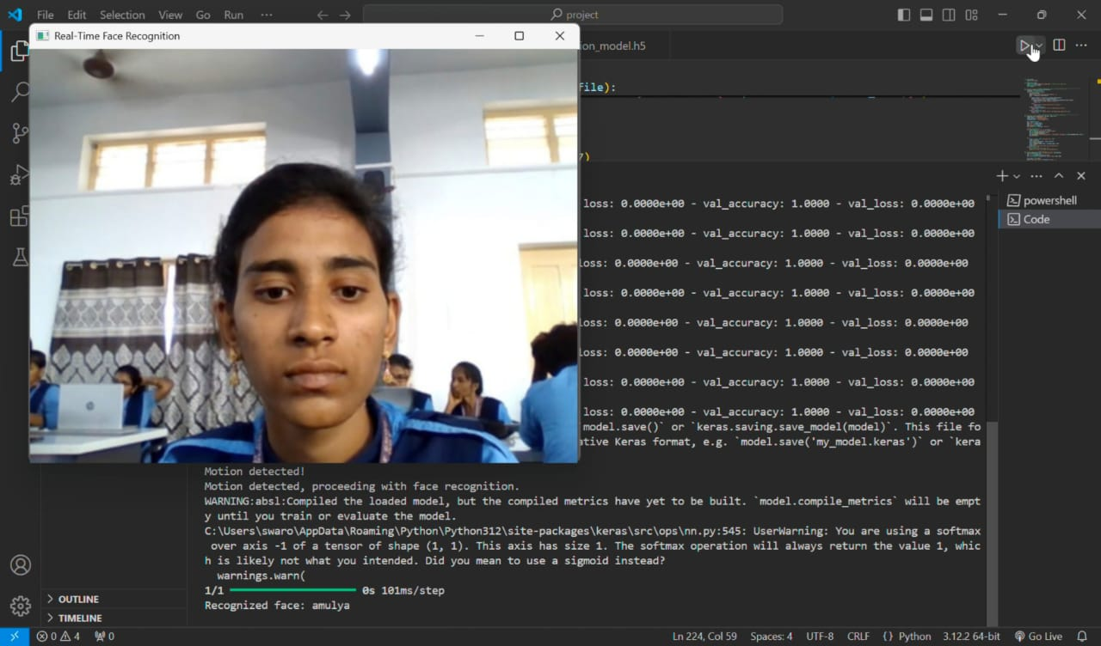

**With unknown faces :**

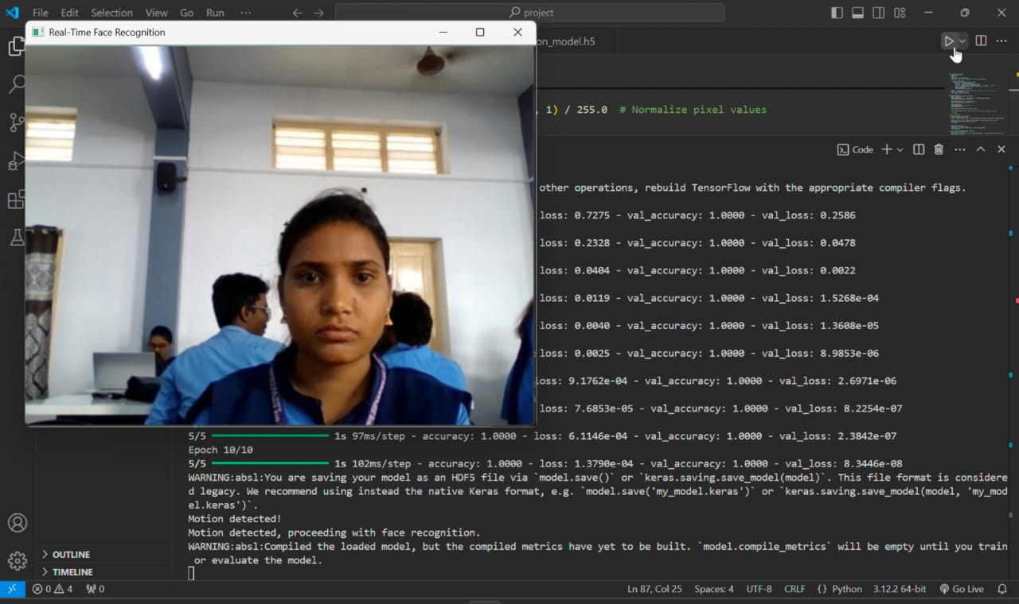

**4.3 Sentence Recognition**

**Observation**:  
The sentence recognition module provided a reliable second layer of authentication. By converting audio input into text, it accurately verified authorized sentences spoken by users.

**Performance Metrics**:

* **Accuracy**: 85% accuracy in recognizing authorized sentences, with minor errors due to background noise or unclear speech.
* **Response Time**: The system took 2-3 seconds to process and validate the spoken sentence.

**Discussion**:  
The SpeechRecognition library and Google’s API performed well in quiet environments but faced difficulties in noisy settings or with heavily accented speech. Adding noise cancellation or fine-tuning the speech recognition model could improve results in such scenarios.

**When known message is recognised :**

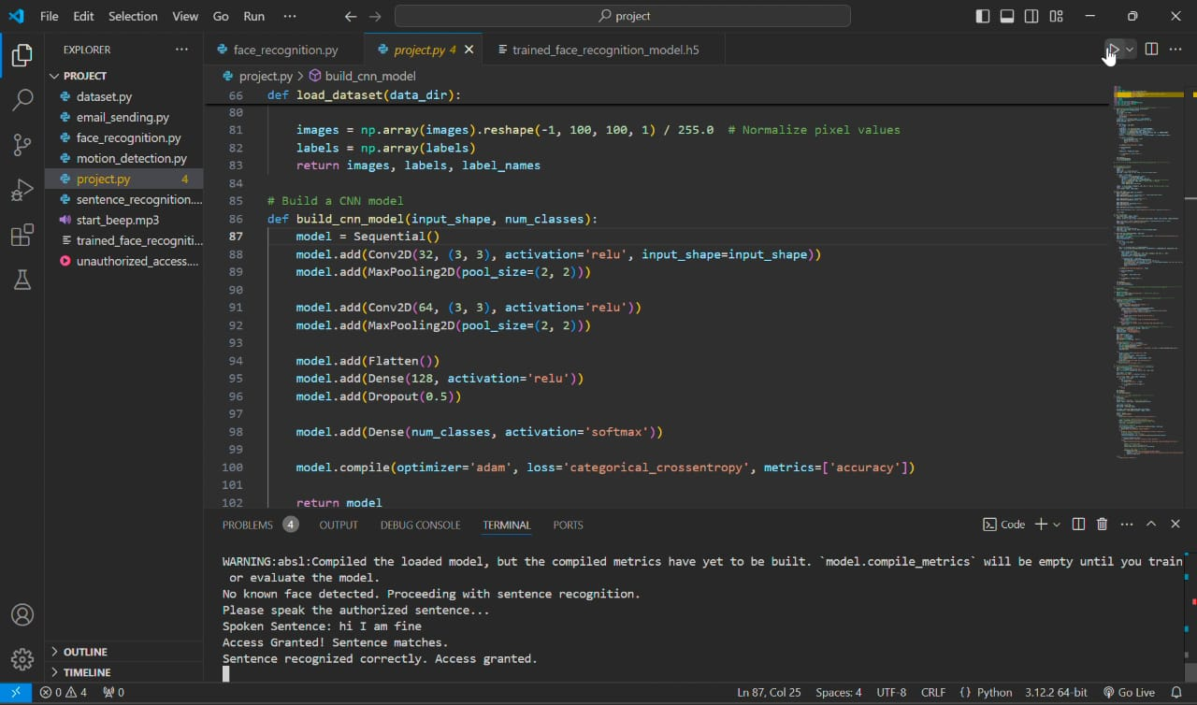

**When unknown message recognise :**

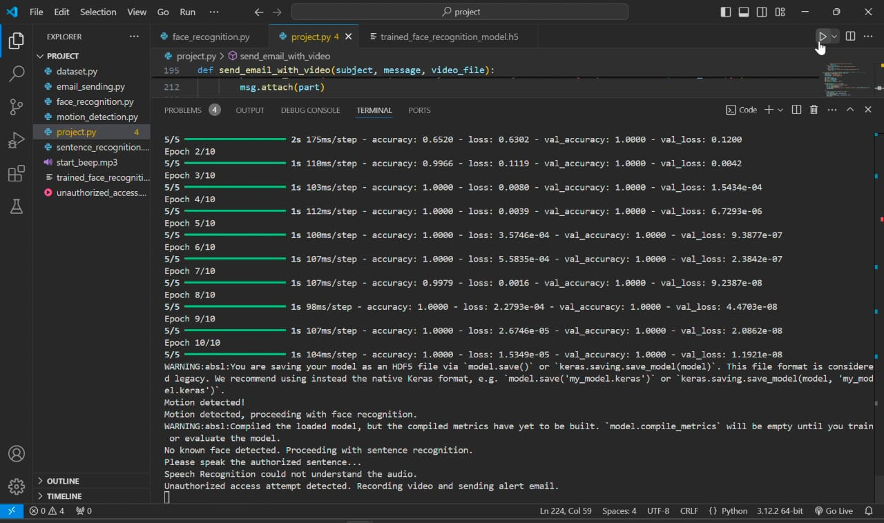

**4.4 Email Alert System**

**Observation**:  
When both facial and sentence recognition failed, the system successfully triggered the email alert module. The recorded 10-second video was attached to the email and delivered to the user in near real-time.

**Performance Metrics**:

* **Email Delivery Time**: 5-10 seconds after the failed recognition attempt.
* **Video Quality**: The recorded video was clear, with a resolution of 720p and 20 FPS.

**Discussion**:  
The automated email alert system ensured that users were informed of potential security breaches promptly. The inclusion of video evidence provided added context, allowing users to verify the nature of the threat. Minor delays in email delivery were observed in cases of slow internet connections.

**After sending email :**

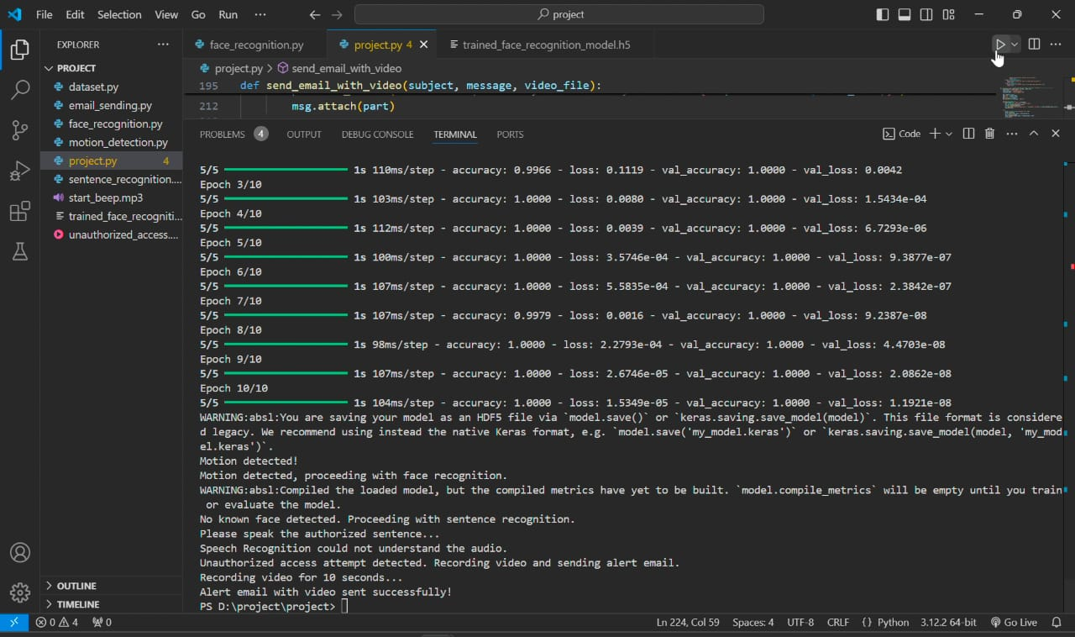

**4.5 Overall System Performance**

**Observation**:  
The system operated seamlessly, transitioning between modules as intended. The integration of motion detection, facial recognition, sentence recognition, and email alerts created a robust and comprehensive security solution.

**Performance Metrics**:

* **End-to-End Time**: Approximately 8-12 seconds for the complete process, from motion detection to email alert.
* **System Uptime**: The system demonstrated stable performance during continuous operation over extended periods.

**Discussion**:  
The system's ability to handle multiple layers of authentication ensures a low false-positive rate and high reliability. However, improvements in hardware (e.g., a dedicated GPU) could reduce processing times further. Additionally, optimizing algorithms for low-light and noisy environments could enhance overall system usability.

**4.6 Challenges**

1. **Environmental Factors**:
   * Low-light conditions impacted facial recognition accuracy.
   * Background noise affected sentence recognition performance.
2. **Hardware Limitations**:
   * Processing times could be further optimized with more powerful hardware.
3. **Dataset Limitations**:
   * Recognition accuracy depends heavily on the quality and diversity of the training dataset.

**4.7 Suggestions for Improvement**

1. **Enhancing Dataset Diversity**:
   * Include images of faces in various lighting conditions, angles, and expressions to improve facial recognition accuracy.
2. **Improving Speech Recognition**:
   * Integrate noise-canceling techniques or train the system with accented speech datasets.
3. **Upgrading Hardware**:
   * Use a dedicated GPU to accelerate the CNN model's processing time and enhance system performance.
4. **Real-time Optimization**:
   * Implement parallel processing for motion detection and recognition modules to reduce end-to-end response time.

**5.Conclusion**

The **AI-Based Smart Security System** successfully demonstrates the integration of advanced technologies such as motion detection, facial recognition, and sentence recognition into a comprehensive security solution. By utilizing a camera for real-time monitoring, a CNN model for facial recognition, and speech recognition for voice-based authentication, the system provides multi-layered security to ensure accurate and reliable access control. In cases of failed recognition, the system promptly sends an email alert with a recorded 10-second video, enabling users to take immediate action. The project addresses the limitations of traditional security systems by automating the detection and notification processes, reducing false alarms, and enhancing overall efficiency. Despite challenges such as environmental factors and hardware limitations, the system proves to be robust and scalable for various applications, including residential, commercial, and industrial spaces. Future enhancements, such as incorporating mobile notifications, improving recognition algorithms for diverse conditions, and optimizing hardware resources, can further elevate the system’s performance and adaptability. This project marks a significant step toward smarter, AI-driven security solutions that prioritize accuracy, automation, and real-time response.

**6. Future Scope**

The **future scope** of the AI-Based Smart Security System lies in its potential to evolve into an even more sophisticated and adaptable security solution. Enhancements can focus on improving the system’s accuracy and performance in challenging environments, such as low-light conditions and noisy settings, by incorporating advanced deep learning models and noise-canceling techniques. Integration with mobile applications can offer users real-time alerts and control, allowing them to remotely monitor and manage security events. Expanding the training dataset with more diverse facial images and voice samples will further enhance recognition accuracy across varying demographics and accents. Additionally, the system could leverage edge computing for faster processing, reducing dependency on high-end hardware while enabling deployment on compact devices like Raspberry Pi. Advanced features, such as multi-camera support for larger areas and predictive analytics to identify suspicious behavior, can further bolster its effectiveness. The inclusion of biometric authentication, such as fingerprint or retina scans, could provide an additional layer of security. These advancements will make the system more scalable and versatile, suitable for applications ranging from small homes to large-scale enterprises. As AI technologies continue to advance, this system has the potential to set new benchmarks in intelligent and automated security solutions.

7.**References / Bibliography**

1. [1]. N. Sulman, T. Sanocki, D. Goldgof and R. Kasturi, How effective is human video surveillance performance?, 19th International Confer ence on Pat tern Recognition, Tampa, FL, 2008, pp.1-3R.
2. [2]. R.J. Radke, S. Andra, O. Al-Kofahi and B. Roysam, Image change detection algorithms: A systematic survey, IEEE Trans. Image Process. 14 (2005) 294–307.
3. [3]. M. Cristani, M. Farenzena, D. Bloisi and V. Murino, Background Subtraction for Automated Multisensor Surveillance: A Compreh en sive Review, EURASIP Journal on Advances in Signal Processing 2010 (2010) 343057.
4. [4]. T. Bouwmans, F. El Baf, and B. Vachon, Statistical background modeling for foreground detection: A survey, Handbook of Pat tern Recognit ion and Computer Vision (Volume 4). Singapore: World Scient ific, 2010.
5. [5]. T. Bouwmans, Recent advanced statistical backgro und mod el in g fo r foreground detection: A systematic survey, Recent Patents Comput.Sci.4(2011)147–176.
6. [6]SanaGhafoor,MuhammadRizwanTahir.(2020 ).ResearchGate. [https://www.researchgate.net/publication/34 1261991](https://www.researchgate.net/publication/34%201261991)
7. [7] Asif Rahim , Yanru Zhong , Tariq Ahmad. (2023). International Journal for Research in Applied Science & Engineering Technology (IJRASET). <https://doi.org/10.22214/ijraset.2023.50243>
8. [8] Prashant Katiyar, Satish Singh, Ankit Kumar, Mr. Gautam Kumar,(2021). International Journal For Technological Research In Engineering(ISSN).
9. [9] Nourman S. Irjanto , Nico Surantha.(2020). International Journal of Advanced Computer Science and Applications(IJACSA).
10. [10] AKM Jahangir Alam Majumder.(2020). ResearchGate/ 2020 IEEE 44th Annual Computers, Software, and Applications Conference(COMPSAC).
11. [11] Nitika Vats Doohan, Sandeep Kadam, Rajesh Phursule, Vinod S. Wadne, and Aparna Junnarkar (2022). International Journal of Electrical and Electronics Research (IJEER ).
12. [12] Nourman S. Irjanto, Nico Surantha. (2020). (IJACSA) International Journal of Advanced Computer Science and Applications. 8.Aman Sharma,Aanjana Goen(2018). Research gate.
13. [13]Aman Sharma,Aanjana Goen(2018). Research gate